AIML

Client Document with Geotag Pictures

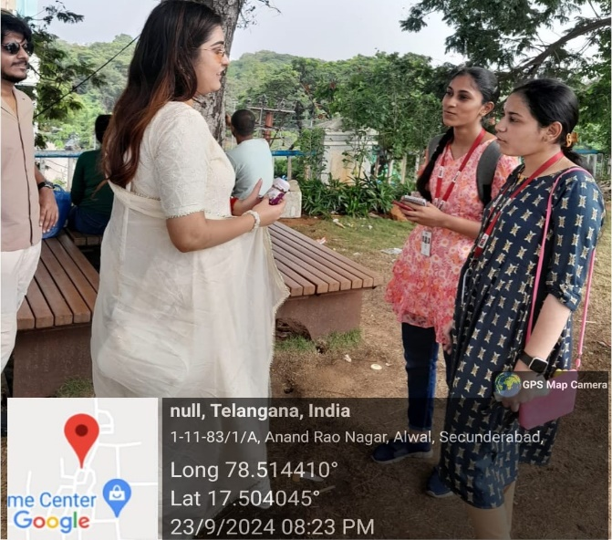 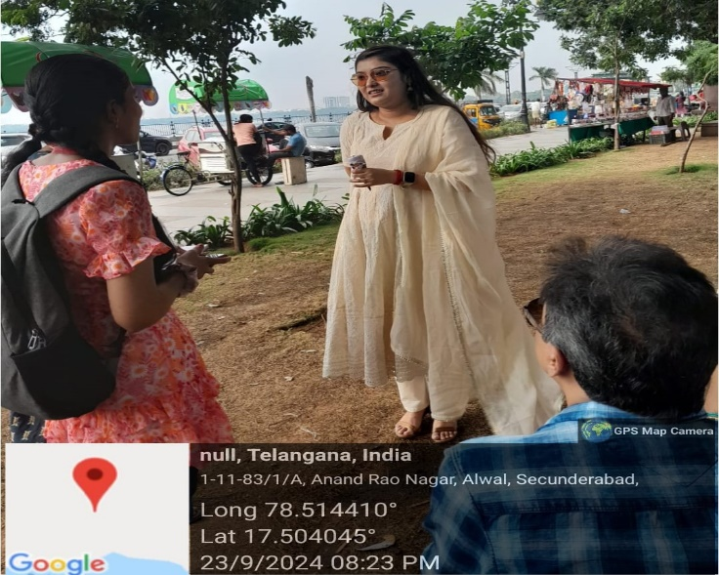

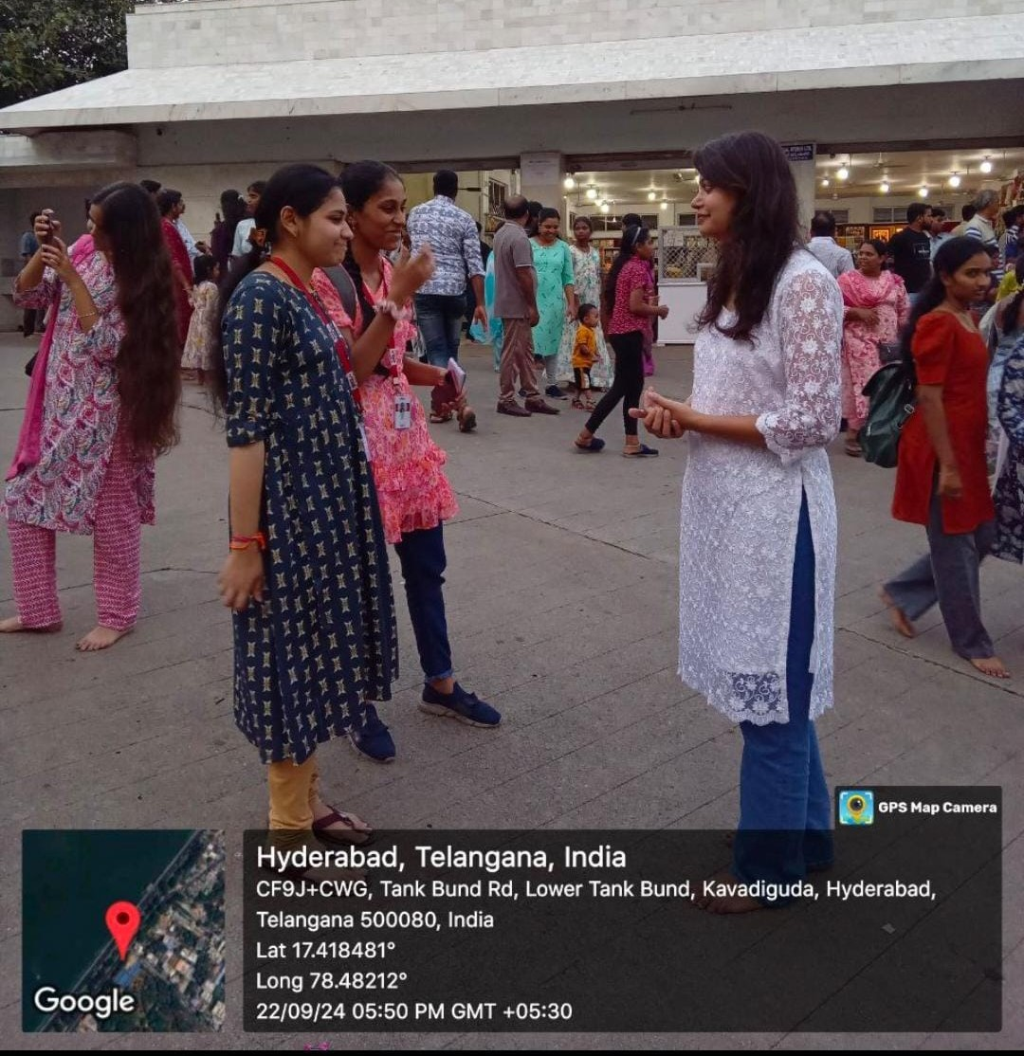

Questions:

1)Do you often use translation apps while traveling?

ANS) YES

2)If yes, do you find the translations accurate most of the time?

Speed and Accuracy:

ANS YES, MOST OF THE TIME

3)What Features do you find most helpful in a language translation tool ?

ANS if there are features like voice recognition which records and understands our language and provides the results faster and accurately ,it would be helpful

4)Would you trust a machine learning translator for important conversations like asking for directions dealing with an emergency ?why & why not ?

Ans. Yes ,in case of asking directions mostly ,they are shown in English ,but it would be helpful if they are also shown in various other languages

5)What improvements would you like to see in machine translation tools to enhance your travel experience ?

Ans. if there are features like voice recognition which records and understands our language and provides the results faster and accurately ,it would be helpful

6) Would you prefer faster translations even if they’re less accurate, or slower but more accurate translations?

Ans. I’d prefer slightly slower translations if they’re more accurate, especially when it comes to important conversations like asking for directions or understanding cultural nuances

7) How important is it for you to get instant translations during a conversation when traveling?

Ans. Instant translation isn’t always necessary for me, but it definitely helps in situations like ordering food or negotiating prices in markets

8) Have you ever faced difficulties with translating certain words or phrases when using a translation app?

Ans. Yes, especially with idiomatic expressions. Some phrases don’t translate well and end up confusing the locals or giving a wrong meaning

9) **Which languages do you most often need help with translating while traveling?**

*A*ns. Mostly Asian languages like Mandarin and Japanese. I travel to East Asia a lot, and these languages are tricky for me.

10) How easy or difficult do you find using translation apps? Is there anything specific about these apps that frustrates you?

Ans. Most of the time they’re easy to use, but I get frustrated when they don’t work offline. It’s hard when there’s no internet in remote places

11) Do you think translation apps handle culturally sensitive expressions well? Have you ever encountered any issues where the app didn’t convey the right tone or meaning?

Ans. Not always. I’ve had a few situations where something got lost in translation, and I could tell it didn’t convey the right politeness

12) Would you appreciate translation apps that include local cultural tips or context along with translations?

Ans. Yes, having cultural context would be a great feature, especially in countries where there are a lot of unwritten social rules